**Part A: Micro-Project Proposal**

**Employee RecordManagement System**

1. **Aims/Benefits of the Micro-Project**

To develop employee record management system which will be able to add, update, display and search employee related information.

1. **Course Outcomes Addressed**
2. Develop programs using Object Oriented Methodology in Java
3. Apply concept of Inheritance for code reusability
4. Implement Exception Handling
5. **Proposed Methodology**

Employee record management system, we accept display search and update the data is given below.

Step 1:- Firstly, Enter numbers of records you want to store.

Step 2:- Display the menu 1. Accept 2. Display 3. Search 4. Update 5. Exit

Step 3:- Enter your choice.

Step 4:- If choice 1 then enter the details of employee that you enter the number of records.

If choice 2 then display all records in tabular format.

If choice 3 then enter the employee id whose you want to search the record

If choice 4 then enter the employee id you want to update.

If choice 5 then exit the program.

1. **Action Plan**

|  |  |  |  |  |
| --- | --- | --- | --- | --- |
| **Sr. No.** | **Details of Activity** | **Planned Start Date** | **Planned Finish Date** | **Name of Responsible**  **Team Members** |
| 1 | Data Collection | 2/4/2022 | 8/4/2022 | Khushi surana |
| 2 | Analysis | 9/4/2022 | 15/4/2022 | Vrushali thakur |
| 3 | Design | 16/4/2022 | 29/4/2022 | lalit shirsath |
| 4 | Development (Program Coding) | 30/4/2022 | 6/5/2022 | Chetan patil |
| 5 | Report Writing | 7/5/2022 | 14/5/2022 | Gayatri salunkhe |

1. **Resources Required**

|  |  |  |  |  |
| --- | --- | --- | --- | --- |
| **Sr. No.** | **Name of Resource/Material** | **Specification** | **Quantity** | **Remark** |
| 1 | Computer System | **OS:** Windows 7 (32 bit)  **Processor:** Intel(R) Pentium(R) Dual CPU E2140 @ 1.60GHz 1.60GHz  **RAM:** 2GB | 1 | - |
| 2 | Software | jdk 1.8.0 | 1 | - |

**Name of Team Members with Roll Numbers**

72 Khushi Amit Surana

77 Chetan Bhatu patil

87 Gayatri Ravindar Salunkhe

88 Lalit Prabhakar Shirsath

89 Vrushali Vijaysing Thakur

**Part B-Micro-Project Report**

**Employee Record Management System**

1. **Introduction**

To develop employee record management system which will be able to add ,update ,display and search employee related information. In getData method we can accept the employee id, employee name ,contactnumber ,emailed ,designation and salary. In search method we enter employee id that we want to search if it is present in the record then display the information of entered employee id. In update method we enter the employee id that we want to update and also accept the updated information.

1. **Aims/Benefits of the Micro-Project**

To develop employee record management system which will be able to add, update, display and search employee related information.

1. **Course Outcomes Achieved**
2. Develop programs using Object Oriented Methodology in Java
3. Apply concept of Inheritance for code reusability
4. Implement Exception Handling
5. **Actual Methodology Followed**
6. getData ()method is used for accepting about employee
7. display() method is used for displaying the information in tabular formate.
8. Search () method is used for searching the information that we want to search
9. update() method is used for updating the information that we want to update.

import java.io.*;

class Employee

{

intempId;

String name, contact_no ,email_id ,designation;

float salary;

voidgetData()throws IOException

{

inti=0;

DataInputStream d=new DataInputStream(System.in);

System.out.println("Enter the details of Employee: ");

System.out.print("Enter the Employee id: ");

empId=Integer.parseInt(d.readLine());

System.out.print("Enter the Employee name: ");

name=d.readLine();

System.out.print("Enter the Salary: ");

salary=Float.valueOf(d.readLine());

System.out.print("Enter the Designation: ");

designation=d.readLine();

System.out.print("Enter the Email-id: ");

email_id=d.readLine();

System.out.print("Enter the Contact: ");

contact_no=d.readLine();

System.out.println("*****************************************");

}

void search(Employee e[],intn,intei)

{

inti,flag=0;

for(i=0;i<n;i++)

{

if(ei==e[i].empId)

{

flag=1;

break;

}

}

if(flag == 1)

{

System.out.println("********************************");

System.out.println("Name: "+e[i].name);

System.out.println("Designation: "+e[i].designation);

System.out.println("Email ID: "+e[i].email_id);

System.out.println("Contact No: "+e[i].contact_no);

System.out.println("********************************");

}

else

System.out.println("Employee is not found.");

}

void update(Employee e[],int n)throws IOException

{

inteId,flag=0;

floatsal;

String designation1,eid,con;

DataInputStream d = new DataInputStream(System.in);

System.out.println("Enter Employee ID you want to update: ");

eId=Integer.parseInt(d.readLine());

System.out.println("<<<What You Want to update??>>> ");

System.out.println("1.EMPLOYEE'S SALARY\n2.EMPLOYEE'S EMAIL ID");

System.out.println("3.EMPLOYEE'S CONTACT NO\n4.EMPLOYEE'S DESIGNATION");

int N = Integer.parseInt(d.readLine());

if(N==1)

{

System.out.println("Enter the salary you want to update: ");

sal=Float.valueOf(d.readLine());

for(inti=0;i<n;i++)

{

if(eId==e[i].empId)

{

e[i].salary=sal;

flag=1;

}

}

}

else if(N==2)

{

System.out.println("Enter the email id you want to update: ");

eid=d.readLine();

for(inti=0;i<n;i++)

{

if(eId==e[i].empId)

{

e[i].email_id=eid;

flag=1;

}

}

}

else if(N==3)

{

System.out.println("Enter the contact no you want to update: ");

con=d.readLine();

for(inti=0;i<n;i++)

{

if(eId==e[i].empId)

{

e[i].contact_no=con;

flag=1;

}

}

}

else

{

System.out.println("Enter the designation you want to update: ");

designation1=d.readLine();

for(inti=0;i<n;i++)

{

if(eId==e[i].empId)

{

e[i].designation=designation1;

flag=1;

}

}

}

if(flag==1)

System.out.println("Information updated.......");

else

System.out.println("Information not updated......");

}

void display()

{

System.out.printf("%-20d %-20s %-20f %-20s %-20s %-20s",empId,name,salary,designation,email_id,contact_no);

}

public static void main(String args[])throws IOException

{

DataInputStream d=new DataInputStream(System.in);

Employee e[];

int n=0;

inti,ch;

System.out.println("Enter number records to create:");

n=Integer.parseInt(d.readLine());

e=new Employee[n];

for(i=0;i<n;i++)

e[i]=new Employee();

while(true)

{

System.out.println("*****<<<<<MENU>>>>>*****");

System.out.println("1 : ACCEPT THE EMPLOYEE INFORMATIOON");

System.out.println("2 : DISPLAY THE EMPLOYEE INFORMATION");

System.out.println("3 : SEARCH THE EMPLOYEE INFORMATION");

System.out.println("4 : UPDATE THE EMPLOYEE INFORMATION");

System.out.println("5 : EXIT");

System.out.println("Enter your choice: ");

ch=Integer.parseInt(d.readLine());

switch(ch)

{ case 1:for(i=0;i<n;i++)

e[i].getData();

break;

case 2:System.out.printf("%-20s %-20s %-20s %-20s %-20s %-20s ","Emp_id","Name","Salary","Designation","Email_id","Contact_No");

for(i=0;i<n;i++)

e[i].display();

break;

case 3:System.out.println("Enter Employee id to search:");

intei=Integer.parseInt(d.readLine());

e[0].search(e,n,ei);

break;

case 4:System.out.println("<<<<UPDATE THE DATA>>>>");

e[0].update(e,n);

break;

case 5:System.exit(0);

}

}

}

}

1. **Actual Resources Required**

|  |  |  |  |  |
| --- | --- | --- | --- | --- |
| **Sr. No.** | **Name of Resource/Material** | **Specification** | **Quantity** | **Remark** |
| 1 | Computer System | **OS:** Windows 7 (32 bit)  **Processor:** Intel(R) Pentium(R) Dual CPU E2140 @ 1.60GHz 1.60GHz  **RAM:** 2GB | 1 | - |
| 2 | Software | jdk 1.8.0 | 1 | - |

1. **Output of Micro-Project**

Case 1 :Accepting employee details

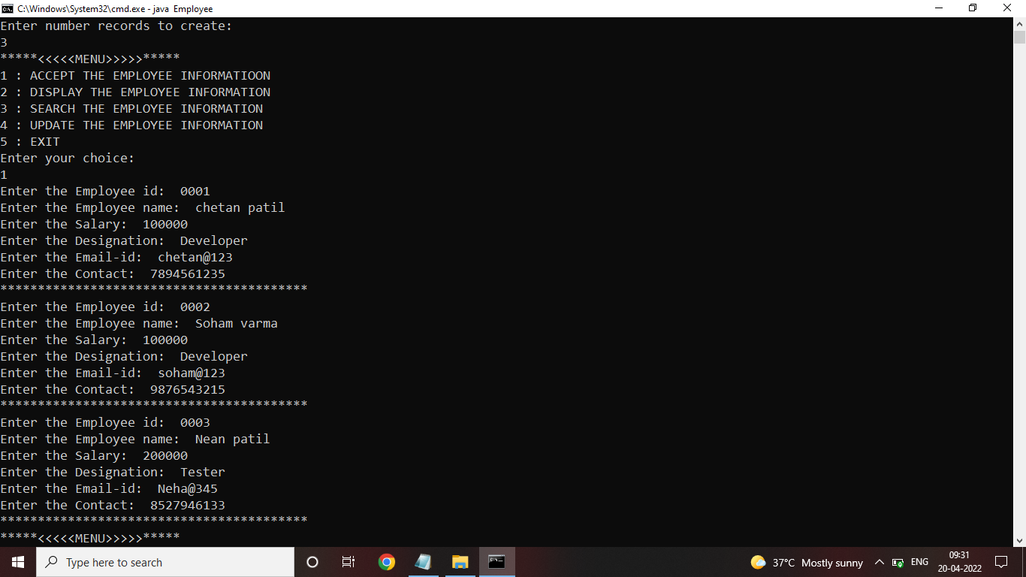

Case 2 :Displaying the information.

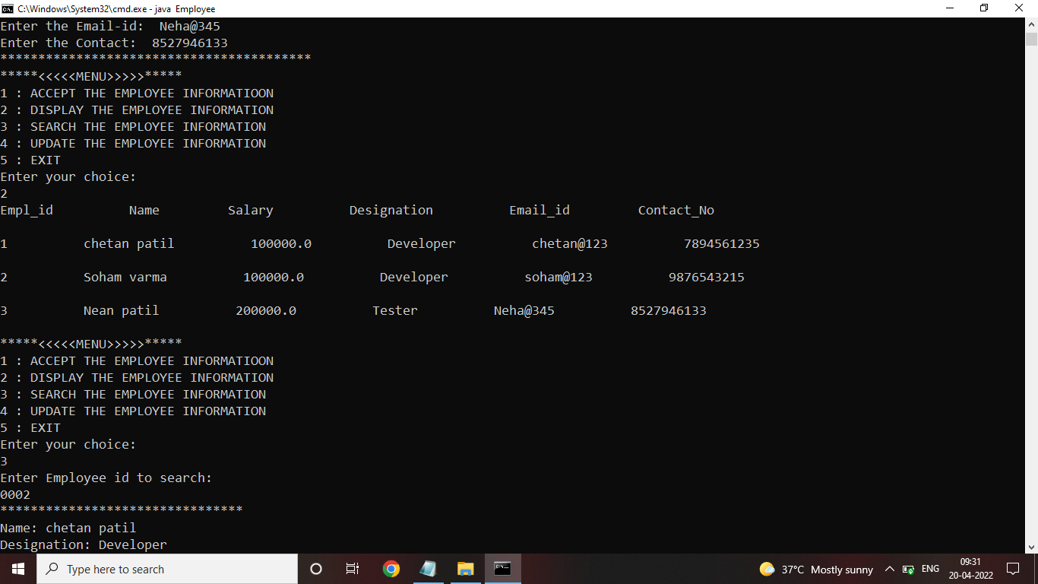

.

Case 3 Searching the information

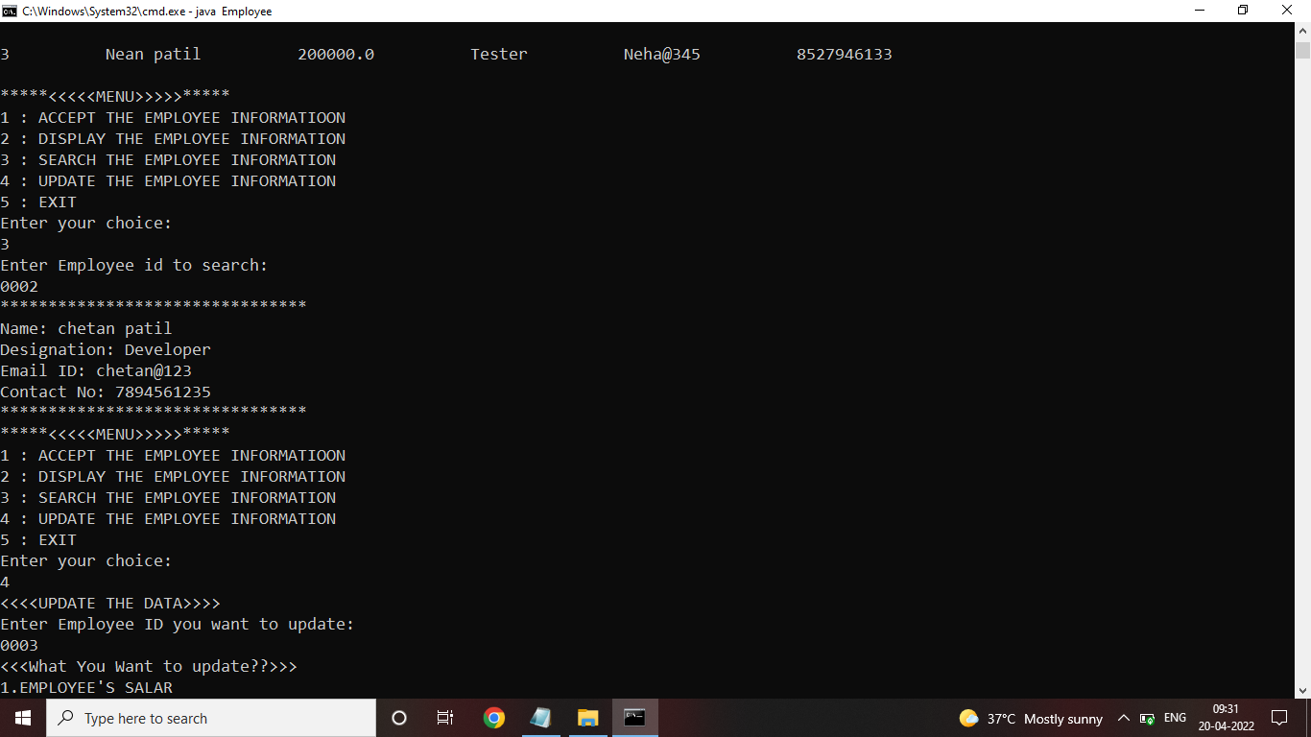

Case 4 : Update the information.

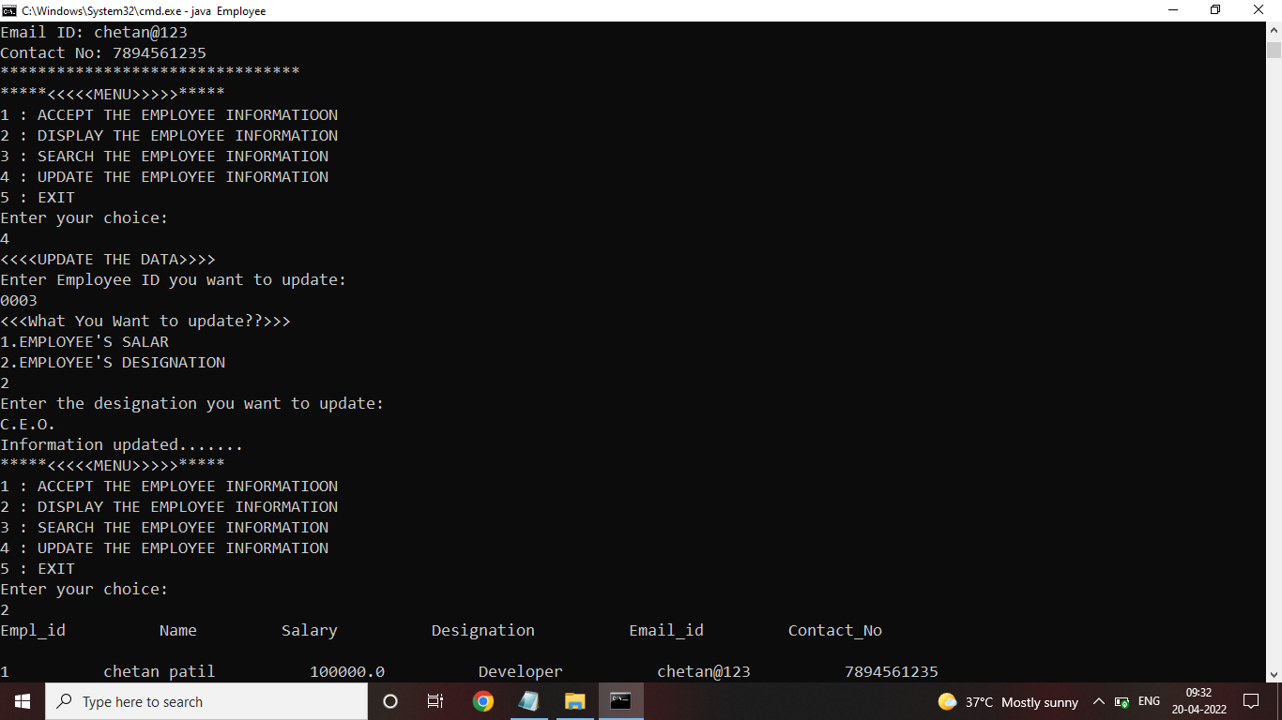

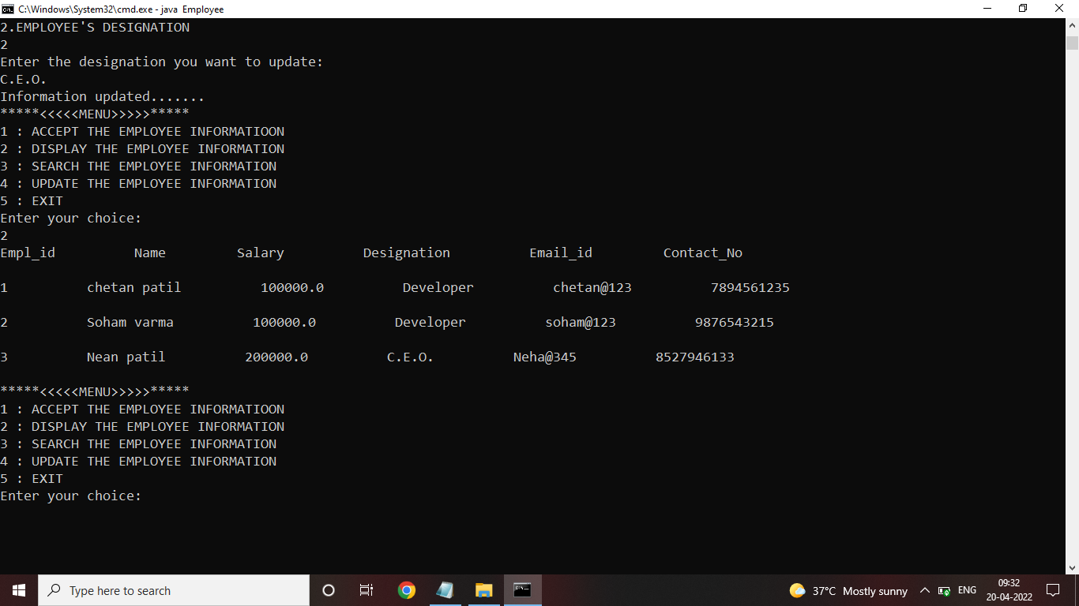

1. **Skill Developed/Learning outcome of this Micro-Project**
2. We learned how to define a class and how to create object of class
3. We learned how to implement the array of object
4. We learned the concept of constructor and also the types of constructor
5. We learned the concept of menu driven program
6. We learned how to implement concept of Exception Handling
7. We learned how to import package in the program
8. **Applications of this Micro-Project**
9. The employee record management system is use in the offices for stored the information of employee.